Matthew Mendenhall, Adam Meismer, Trey Williamson, Sofia Lopez
Dr. Wissam Kontar
30 March 2026
CIVE 202

Project 3 Technical Report
Introduction

This project focused on using Python to organize data provided by the Nebraska Department of Transportation on how Autonomous vehicles record and react to data specifically at road intersections. Mostly, if Autonomous vehicles are safer than human drivers. The client requested 3 tasks for our group to complete. First, use Python to create charts from the provided data set that single out individual categories, making it easier to see and comprehend. Second, use data collected on vehicle trajectories and behaviors. With this, we will generate graphs and visual aids to compare different inputs and outputs to make operating a motor vehicle safer. And third, educate the customer on Python and its abilities to generate charts and graphs. We will share our timetables for each part of this project and give them an idea of what training their own workforce on Python code looks like.
Methods
Variable Selection and Justification
The selection of variables was based on their relevance to the trends in transportation and safety. The selection of variables from the NHTS data set includes:
- Trip Distance (TRPMILES) - to analyze the distances people travel on average.
- Trip Purpose (WHYTRP1) - to group the trips on different reasons to travel.
- Mode of Transportation (TRPTRANS) - to compare different modes of transportation.
- Travel Time (TRVLCMIN) - to evaluate the time consumed in traveling from one point to another.
The selection of variables from the NGSIM data set includes:
- Vehicle Speed - to understand the patterns of driving on the road.
- Vehicle Acceleration - to understand if the vehicle is being driven aggressively or smoothly.
- Vehicle Position (x, y) - to understand the path of driving.
- Time - to understand how long the vehicle has been moving on the road.
- Vehicle Spacing - to understand if the vehicle is following other vehicles at a safe interval or not.
The selection of these variables has been done for analysis based on understanding different macro-level trends and micro-level driving behavior.
Plot Construction
The plots constructed include:
- Bar Chart: This plot is constructed by grouping data on different variables such as purpose of the trip and mode of transportation.
- Histogram: This is created by using continuous variables such as trip distance and travel time. The data is shown based on the frequency of the data.
- Boxplot: This is created to compare data based on different variables such as travel time and purpose of the trip. The data is shown based on the median and quartiles.
- Time Series Plots: This is created by using data from NGSIM. The data is shown based on variables such as speed and acceleration over a period of time to analyze the driving behavior.
All the plots created are customized by changing the color of the plots and other options provided by Matplotlib/Seaborn to make the plots more readable and presentable.
Additional Methods
In addition to data visualization methods, simulation methods are also used. The simulation method is based on the Intelligent Driver Model (IDM), which is a simulation tool for vehicle-following behavior based on variables such as speed, acceleration, and space gap.
The simulation method is used for the following purposes:
- Model realistic driving behavior
- Analyze safe following distances
- Compare theoretical driving behavior with actual data from NGSIM
Data preprocessing involves cleaning the data by removing any missing data and filtering the data based on the variables required for analysis. The data is then preprocessed and stored in Panda’s data structures.

Results & Discussion
3.1 Vehicle Type Distribution by Census Region
The stacked bar chart indicates that the most used vehicle types are automobiles (cars/station wagons) and SUVs. Among these vehicle types, the South census region is seen to have the largest number of vehicles, particularly automobiles and SUVs. This implies that the South Census Region relies most on personal vehicles compared to the other census regions. Furthermore, the stacked bar chart also indicates that pickup trucks are also commonly used in the South and West census regions compared to the Northeast census region. Motorcycles, recreational vehicles, and other vehicle types are seen to have a very small number of vehicle usage among the different census regions.
Figure 1: Stacked Bar Chart
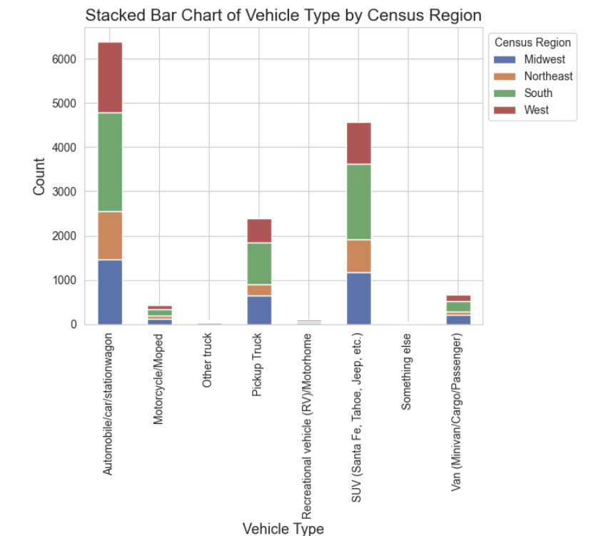
Relevance: The stacked bar chart indicates that transportation infrastructure and policy should focus on the development of road infrastructure for passenger vehicles and SUVs, especially in the South census region where vehicle usage is high.

3.2 Distribution of Vehicle Age
The histogram of vehicle age indicates a right-skewed distribution of vehicle age, showing that most of the vehicles are distributed around the 0-10 years interval, particularly around 4-6 years. The age of the vehicle is seen to decrease significantly as the years progress. However, some of the data points are seen to reach 30-40 years of age.

Figure 2: Histogram
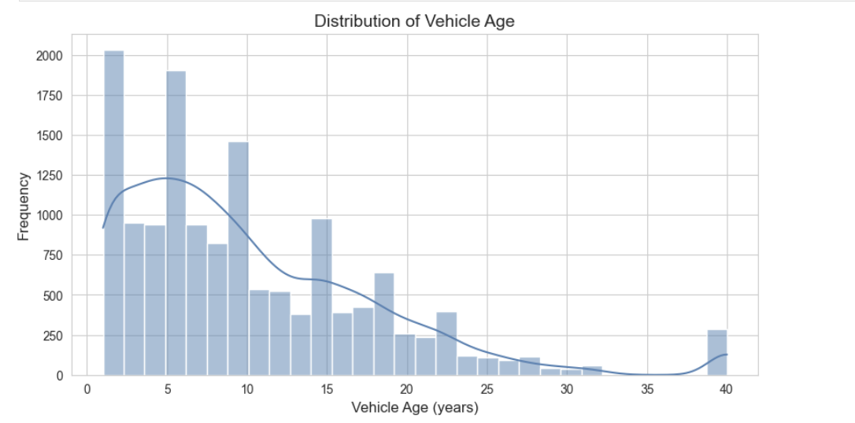
Relevance: The histogram of vehicle age indicates that most drivers are driving relatively modern vehicles that are most likely equipped with modern safety features such as advanced braking systems and driver assistance systems. However, the presence of some data points that reach 30-40 years of age indicate that not all drivers are driving modern vehicles that are equipped with such safety features.

3.3 Vehicles per Household (Urban vs. Rural)
The box plot showing the number of vehicles per household indicates that on average, more vehicles are owned by people living in rural areas compared to those living in urban areas. This is because, on average, more than one vehicle is owned by people living in rural areas, compared to those living in urban areas.
Figure 3: Box Plot
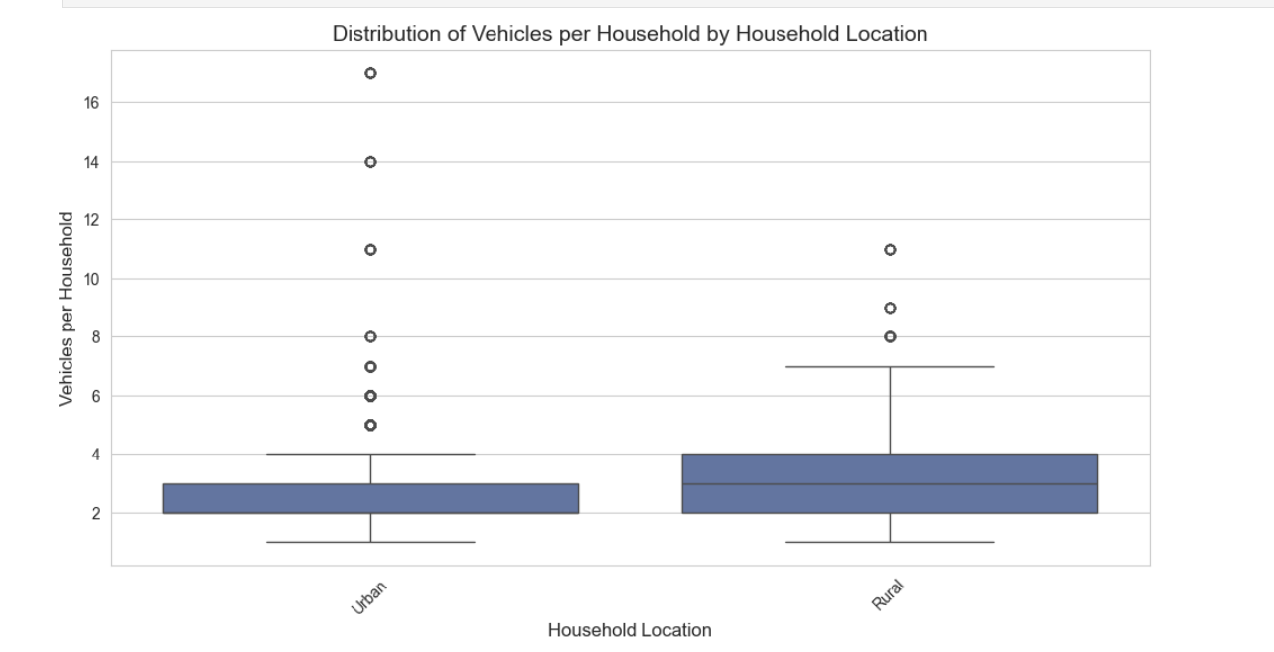
The number of vehicles owned by people living in urban areas ranges from 1 to 3, whereas those living in rural areas range from 1 to 10+.
Relevance: This is because people living in rural areas lack public transport, and owning a vehicle is a necessity.
3.4 Car-Following Behavior: Trajectory Comparison
The trajectory plot indicates that the follower vehicle is following the leader vehicle, but at a slightly lagging position. This lagging position represents a safe distance between two cars.
Figure 4: Trajectory Plot
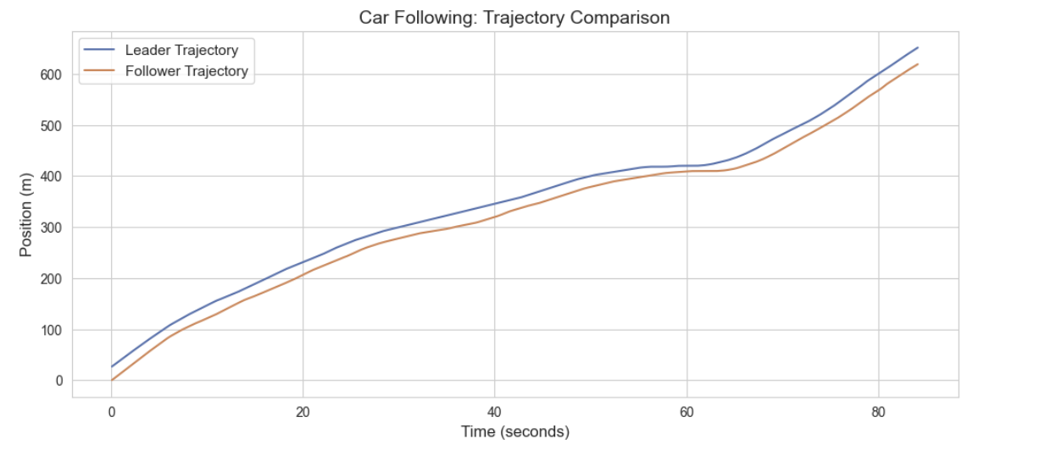

The follower vehicle's trajectory is smooth, indicating a reaction time effect.
Relevance: This plot is important because maintaining a safe distance is critical in preventing accidents.

3.5 Car-Following Behavior: Speed Comparison
The speed comparison plot indicates that both leader and follower vehicles fluctuate in speed, accelerating and decelerating at different times.
Figure 5: Trajectory Plot (Speed Comparison)
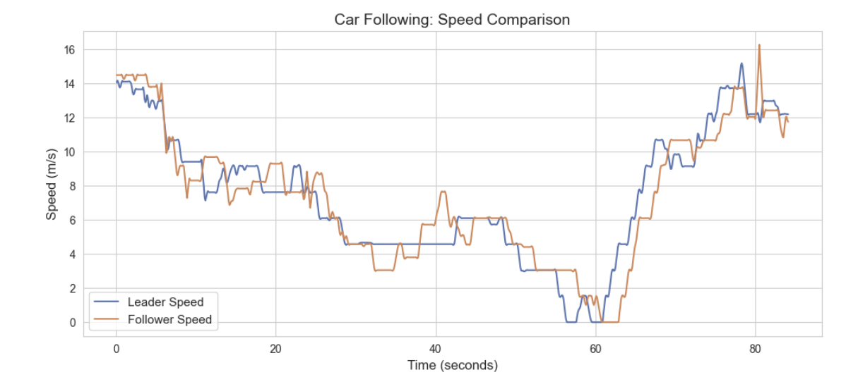
The follower vehicle's speed is almost like that of the leader but slightly lagging.
Relevance: These fluctuations indicate stop-and-go traffic conditions, which are very common in such areas. Such conditions are likely to cause accidents and are not good for the smooth flow of traffic. Therefore, optimization of such conditions is very important for better traffic flow and for the development of intelligent systems for such purposes.
3.6 Trajectory Heatmap Visualization
The above heatmap indicates the vehicle trajectory. The speed of the vehicle is indicated by color. The speed is high at the beginning and end of the trajectory and low in the middle of the trajectory.
Figure 6: Heatmap Visualization
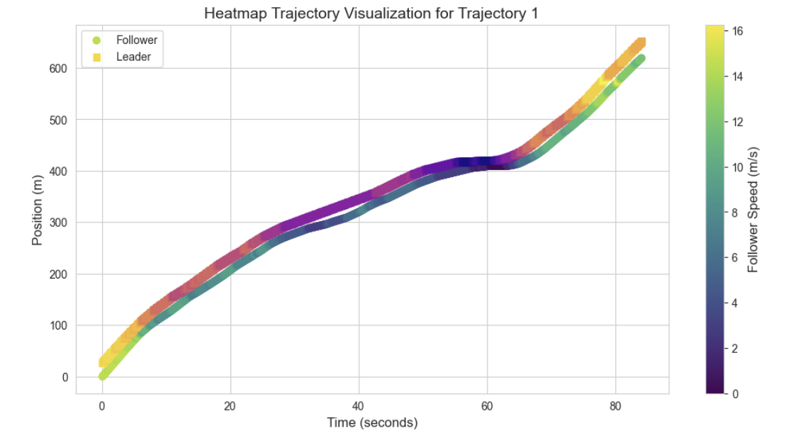
From the above information, the vehicle slows down in the middle of the trajectory and speeds up again after the slowing period is over. Such conditions are very common in real-world scenarios and are not good for the smooth flow of traffic. Therefore, optimization of such conditions is very important for better traffic flow and for the development of intelligent systems for such purposes.
Relevance: The above visualization provides a clear idea about the conditions of the road and the behavior of the vehicle on the road. Such visualization is very important for the development of intelligent systems for such purposes.

3.7 IDM Simulation vs. Real Behavior
The above plot of the IDM simulation indicates that the follower vehicle is very close to the real follower vehicle. The only difference is that the vehicle is a little smoother in the case of the IDM simulation. The acceleration of the vehicle is also shown in the above figure. The acceleration of the vehicle is very high in the case of the real vehicle and is very smooth in the case of the IDM simulation.
Real-world acceleration:

Figure 7: IDM Simulation
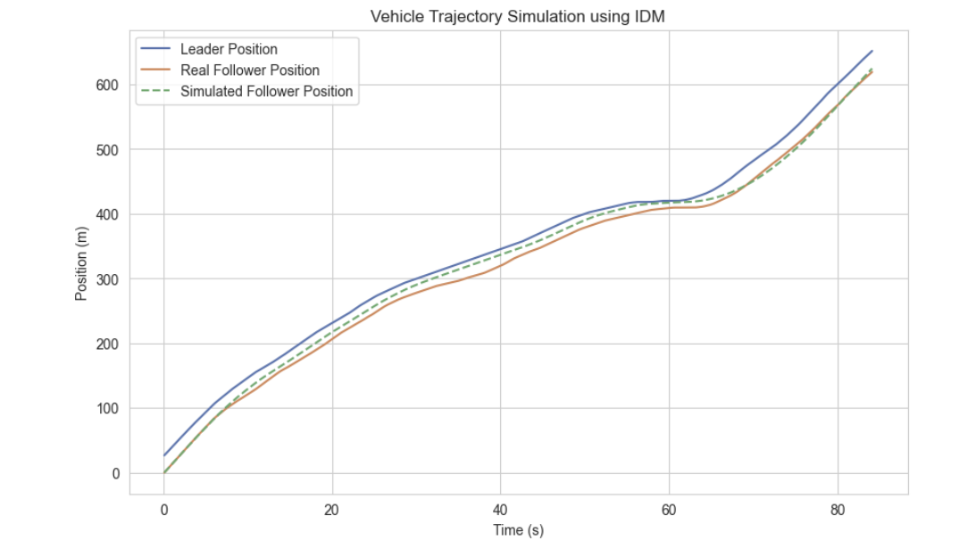
The acceleration of the vehicle is very high in the case of the real vehicle. The fluctuations are also very high in the case of the real vehicle. The positive and negative fluctuations are very sharp in the case of the real vehicle.
Acceleration of the vehicle in the case of IDM simulation:
Figure 8: Acceleration v Time
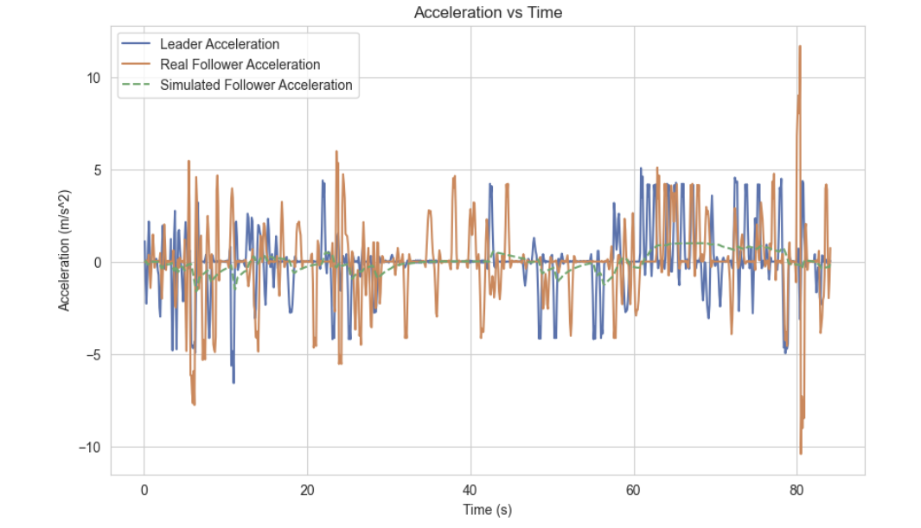
The acceleration of the vehicle is very smooth in the case of IDM simulation. The fluctuations are very low in the case of IDM simulation.
Relevance: From the above information, the Intelligent Driver Model is very smooth and provides better conditions compared to the real vehicle. Such conditions are very important for the development of intelligent systems for such purposes.
References:
Federal Highway Administration (FHWA). National Household Travel Survey (NHTS)
Federal Highway Administration (FHWA). Next Generation Simulation (NGSIM) Dataset
Python Software Foundation. Python Documentation
Matplotlib Development Team. Matplotlib Documentation
Seaborn Development Team. Seaborn Documentation

